**How to open the tutorial notebook?**

**Description: 3 ways to download the notebook Tutorial.ipynb**

**Time: 2 mins.**

As you have set up your JupyterNotebook, you can started to explore it from clicking upload/new or Logout. For the three ways, I usually use the 2ndUpload, but you can choose other methods: from Terminal or kernal(new notebook).

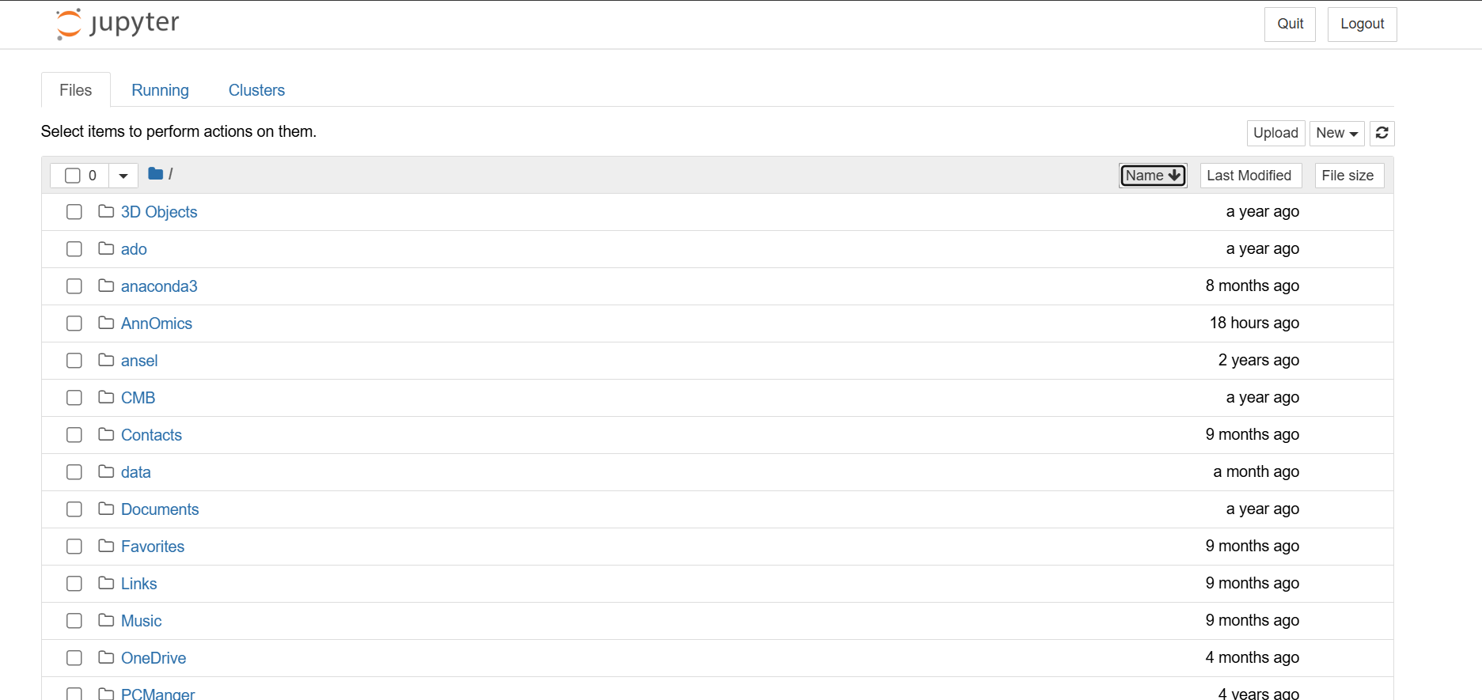

* **1.Terminal**

Open your **terminal** or click **new→terminal** and Enter the following command:

wget https://raw.githubusercontent.com/WanbingZeng/OMINEX/main/Tutorial.ipynb

* **2.Upload**

Download the Tutorial.ipynb through the github link:

[OMINEX/Tutorial.ipynb at main · WanbingZeng/OMINEX (github.com)](https://github.com/WanbingZeng/OMINEX/blob/main/Tutorial.ipynb)

Click **upload** at the top right to open the **Tutorial.ipynb** files.

* **3. A new notebook**

Click **new→Python 3** to create a new **Python3** notebook.

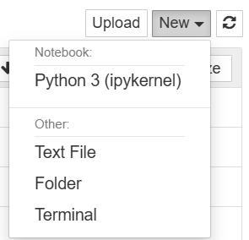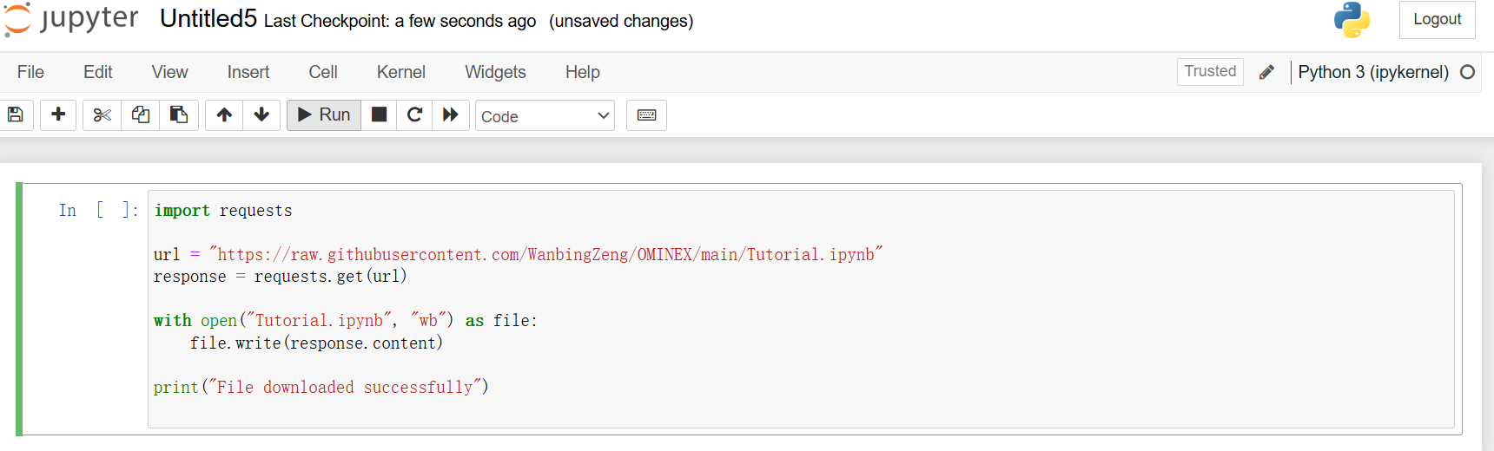

import requests

url = "https://raw.githubusercontent.com/WanbingZeng/OMINEX/main/Tutorial.ipynb"

response = requests.get(url)

with open("Tutorial.ipynb", "wb") as file:

file.write(response.content)

print("File downloaded successfully")

**↑COPY, PASTE and RUN.**

Then you can see the Tutorial.ipynb in your content!

